Week 6 -React Handson
Hands-on 1: Creating a react app ‘cricketapp’
- Creating new React app named ‘cricketapp’ using create-react-app
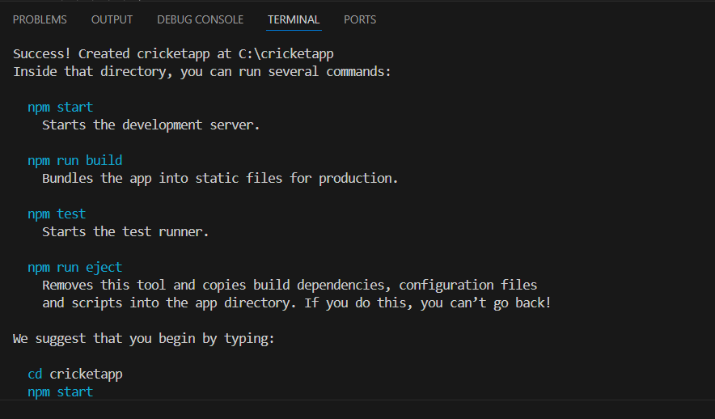
- Creating a component named ’ListOfPlayers’ inside the component folder
- Inside the ListOfPlayers component creating an array of 11 players with their details such as name and score
File name: ListOfPlayer.js
import React from "react";
const ListOfPlayers=()=>{
const players=[
{name:"Virat Kohli" , score:"80"},
{name:"Dhoni" , score:"90"},
{name:"Jadeja" , score:"70"},
{name:"Raahul" , score:"75"},
{name:"Rohit sharma" , score:"80"},
{name:"Hardik Pandya" , score:"65"},
{name:"Bumrah" , score:"70"},
{name:"Shami" , score:"60"},
{name:"Washington Sundar" , score:"55"},
{name:"Sai Sudharshan" , score:"55"},
{name:"Surya", score:"75"}

]
const filterePlayers=players.filter(player => player.score<=70);
return(
<div>
<h2>List of Players</h2>
<ul>
{players.map((player , index)=>(
<li key={index}>{player.name}-{player.score}</li>
))}
</ul>
<h2>Players with score less than 70</h2>
<ul>
{filterePlayers.map((player , index)=>(
<li key={index}>{player.name}-{player.score}</li>
))}
</ul>
</div>
)
}
export default ListOfPlayers;
- Creating a component named ’IndianPlayers’ inside the component folder
- Declaring two arrays T20players and RanjiTrophy players and merging the two arrays and displaying them using the Merge feature of ES6
File name: IndianPlayers.js
import React from "react";
const IndianPlayers = () => {
const T20Players = ["Virat", "Rohit", "Pant", "Bumrah"];
const RanitTrophy = ["Gambir", "Pujara", "Rahane", "Ashwin"];
const allPlayers = [...T20Players, ...RanitTrophy];
const oddPlayers = allPlayers.filter((_, index) => index % 2 !== 0);
const evenPlayers = allPlayers.filter((_, index) => index % 2 === 0);

return (
<div>
<h2>All Indian Players</h2>
<ul>
{allPlayers.map((player, index) => (
<li key={index}>{player}</li>
))}
</ul>

<h2>Odd Players</h2>
<ul>
{oddPlayers.map((player, index) => (
<li key={index}>{player}</li>
))}
</ul>

<h2>Even Players</h2>
<ul>
{evenPlayers.map((player, index) => (
<li key={index}>{player}</li>
))}
</ul>
</div>
);
};
export default IndianPlayers;
- Modifying the App.js to render these components
File name: App.js
import './App.css';
import ListOfPlayers from './components/ListOfPlayers';
import IndianPlayers from './components/IndianPlayers'
function App() {
const flag=false;
return (
<div>
<h1>Cricket App</h1>
{flag?<ListOfPlayers/>:<IndianPlayers/>}
</div>

);
}
export default App;
OUTPUT:
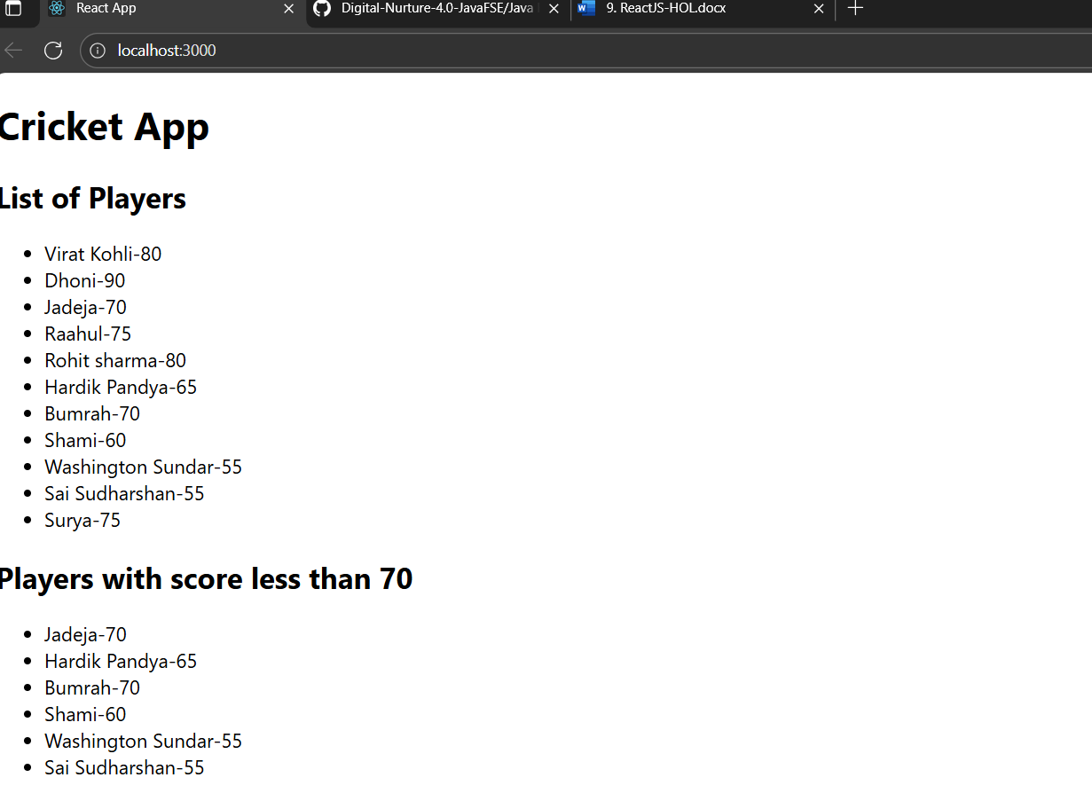
- Changing the flag to false
OUTPUT:
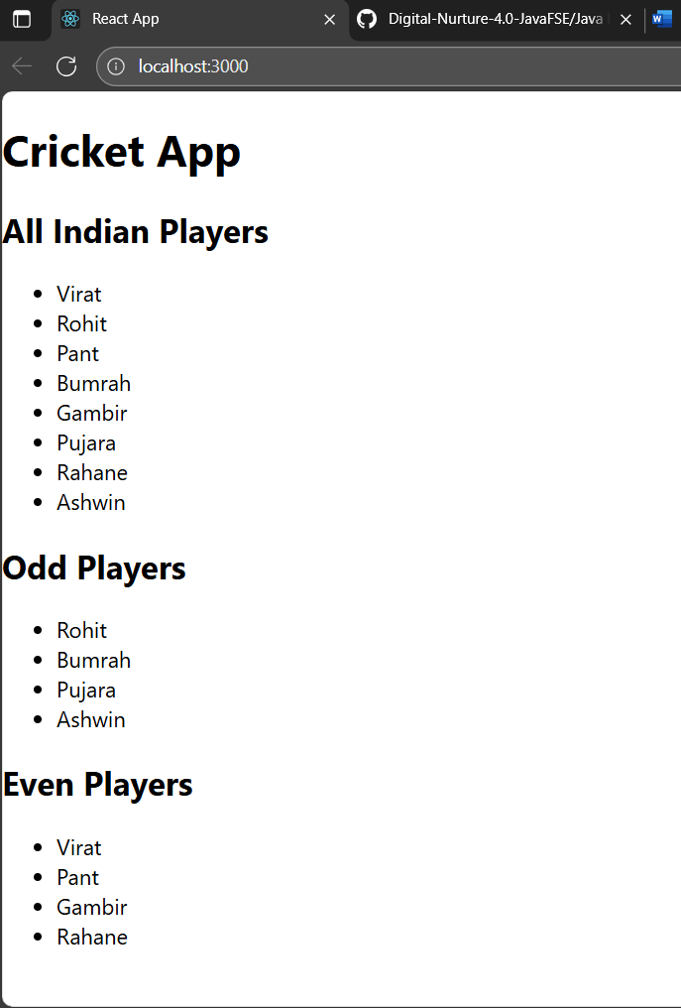
Handson-2: Creating a react app ‘officespacerentalapp’
- Creating a app named ‘officespacerentalapp’ using create-react-app
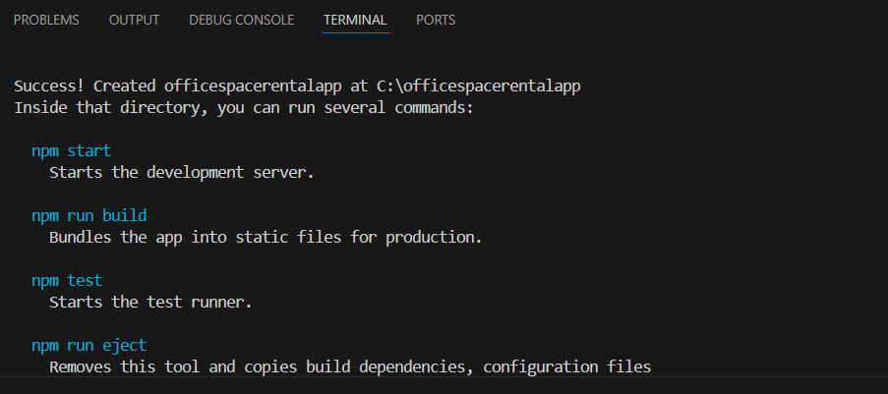

- We modify the “App.js” to use inline CSS and JSX to render the Office Image, Name, Address and Rental cost
File name: App.js
import React from 'react';
function App() {
const offices = [
{
id: 1,
name: 'Nexa work space',
rent: 55000,
address: '15th Street, Gandhi Nagar, Chennai',
image: './off1.png'
},
{
id: 2,
name: 'Green Park',
rent: 70000,
address: '5th Avenue, Anna Nagar, Chennai',
image: './off2.png'
},

];
const headingStyle = {
textAlign: 'center',
color: '#333'
};

return (
<div>
<h1 style={headingStyle}>Office Space Rental App</h1>
{offices.map((office) => (
<div key={office.id} style={{ border: '1px solid #ccc', margin: '10px', padding: '10px' }}>
<img src={office.image} alt={office.name} width="300" height="200" />
<h2>{office.name}</h2>
<p><strong>Address:</strong> {office.address}</p>
<p>
<strong>Rent:</strong>{' '}
<span style={{ color: office.rent < 60000 ? 'red' : 'green' }}>
₹{office.rent}
</span>
</p>
</div>
))}
</div>
);
}
export default App;

OUTPUT:
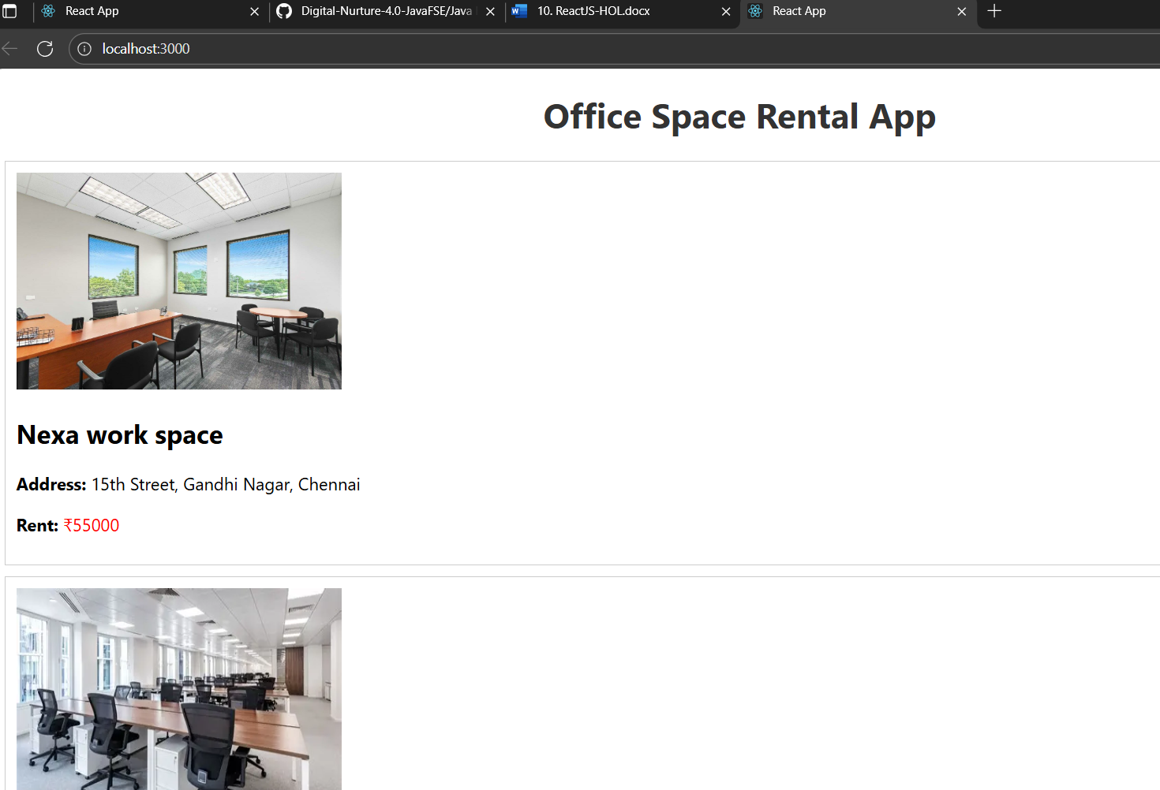

Handson-3: Creating a react app ‘eventexamplesapp’
- Creating a react app named ‘eventexamplesapp’ using create react application
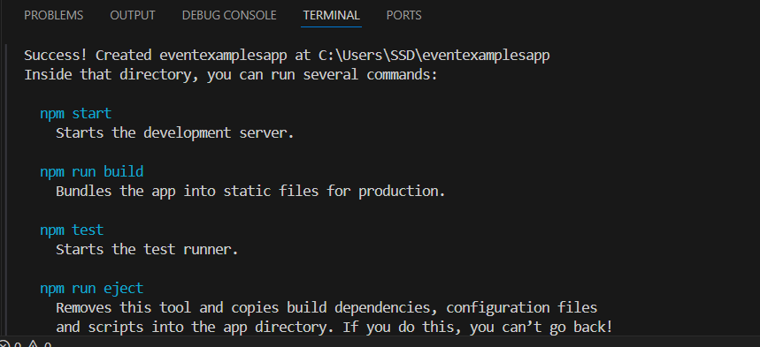
- Creating the components folder inside the src folder. Inside the components folder creating the CounterAndConvertor component

File name: CounterAndConvertor.js
import React, { useState } from "react";

const CounterAndConverter = () => {
const [count, setCount] = useState(0);
const [message, setMessage] = useState("");
const [inr, setInr] = useState("");
const [euro, setEuro] = useState("");
const conversionRate = 0.011;

const handleIncrement = () => {
incrementValue();
sayHello();
};

const incrementValue = () => {
setCount(prev => prev + 1);
};

const decrementValue = () => {
setCount(prev => prev - 1);
};

const sayHello = () => {
setMessage("Hello! This is a static message.");
};

const sayWelcome = (word) => {
alert("Say Welcome button was pressed");
setMessage(Say ${word});
};

const handleClick = () => {
alert("Synthetic OnPress button was pressed");
setMessage("I was clicked");
};

const handleConvert = (e) => {
e.preventDefault();
const inrValue = parseFloat(inr);
if (!isNaN(inrValue)) {
const converted = (inrValue * conversionRate).toFixed(2);
setEuro(converted);
setMessage(${inrValue} INR = ${converted} EUR);
alert(Converted: ₹${inrValue} = €${converted});
} else {
setMessage("Please enter a valid number.");
}
};

return (
<div style={{ padding: 20 }}>
<h2>Counter: {count}</h2>
<button onClick={handleIncrement}>Increment</button>
<button onClick={decrementValue}>Decrement</button>
<br /><br />
<button onClick={() => sayWelcome("Welcome")}>Say Welcome</button>
<br /><br />
<button onClick={handleClick}>Synthetic OnPress</button>
<br /><br />
<h3>Currency Converter (INR ➜ Euro)</h3>
<form onSubmit={handleConvert}>
<input
type="number"
placeholder="Enter INR"
value={inr}
onChange={(e) => setInr(e.target.value)}
/>
<button type="submit">Convert</button>
</form>
{euro && <p>Converted Amount: €{euro}</p>}
<h4>Message: {message}</h4>
</div>
);
};

export default CounterAndConverter;

File name: App.js
import React from "react";
import CounterAndConverter from "./components/CounterAndConvertor";
function App() {
return (
<div>
<CounterAndConverter/>
</div>
);
}
export default App;

OUTPUT:
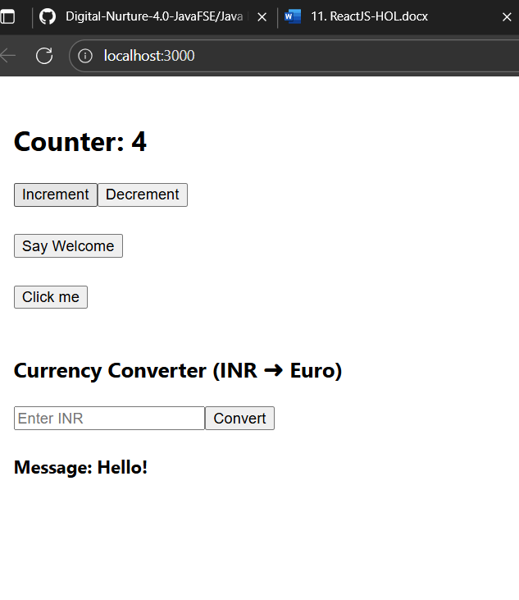

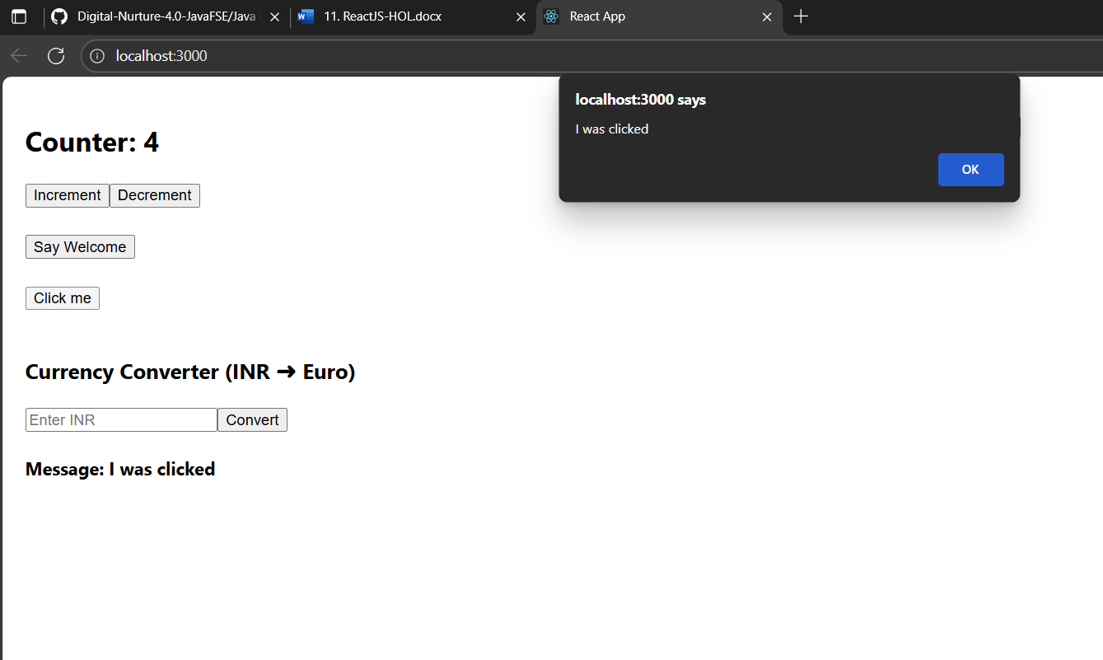
Converting INR to EURO
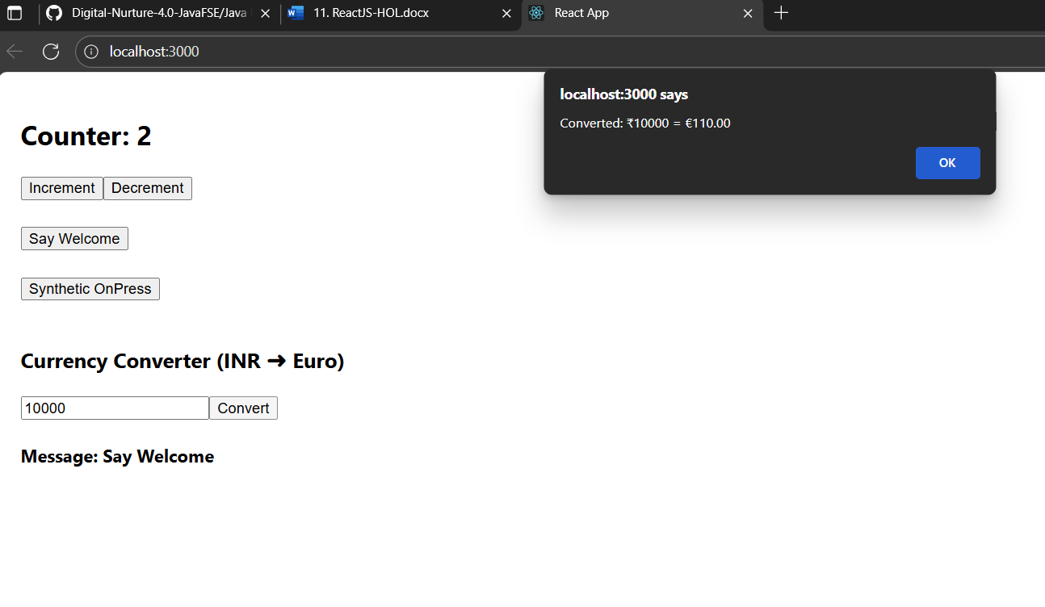

Hands-on 4: Creating a react Ticket booing app
- Creating a react app named ‘ticketbookingapp’ using create-react-app
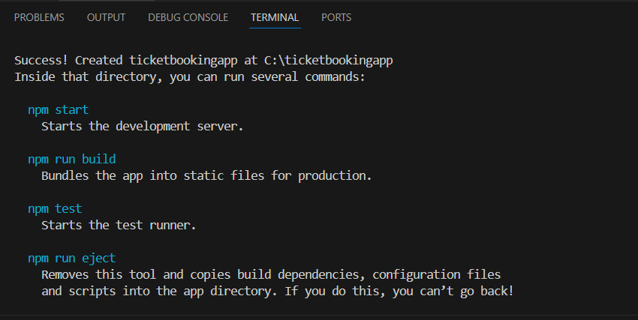
- Creating a components folder under the src folder
- Inside the components folder creating the following components Login.js , Logout.js, GuestPage.js, UserPage.js
File name: Login.js
import React from "react";
const Login = ({ onLogin }) => {
return (
<button onClick={onLogin} style={{ marginBottom: "10px" }}>
Login
</button>
);
};
export default Login;
File name:Logout.js
import React from "react";
const Logout = ({ onLogout }) => {
return (
<button onClick={onLogout} style={{ marginBottom: "10px" }}>
Logout
</button>
);
};
export default Logout;
File name: GuestPage.js
import React from "react";
const GuestPage = () => {
return (
<div>
<h2>Guest View</h2>
<p>Available Flights:</p>
<ul>
<li>Chennai to Bangalore - ₹2500</li>
<li>Delhi to Mumbai - ₹4500</li>
<li>Hyderabad to Kolkata - ₹3000</li>
</ul>
</div>
);
};
export default GuestPage;
File name:UserPage.js
import React from "react";
const UserPage = () => {
return (
<div>
<h2>User Dashboard</h2>
<p>You can now book your flights below:</p>
<ul>
<li>Chennai to Bangalore <button>Book</button></li>
<li>Delhi to Mumbai <button>Book</button></li>
<li>Hyderabad to Kolkata <button>Book</button></li>
</ul>
</div>
);
};
export default UserPage;
- Now modifying the App.js to render these components
import React, { useState } from "react";
import Login from "./components/Login";
import Logout from "./components/Logout";
import GuestPage from "./components/GuestPage";
import UserPage from "./components/UserPage";
function App() {
const [isLoggedIn, setIsLoggedIn] = useState(false);
return (
<div style={{ padding: "20px", fontFamily: "Arial" }}>
<h1> Ticket Booking App</h1>
{isLoggedIn ? (
<>
<Logout onLogout={() => setIsLoggedIn(false)} />
<UserPage />
</>
) : (
<>
<Login onLogin={() => setIsLoggedIn(true)} />
<GuestPage />
</>
)}
</div>
);
}
export default App;
OUTPUT:
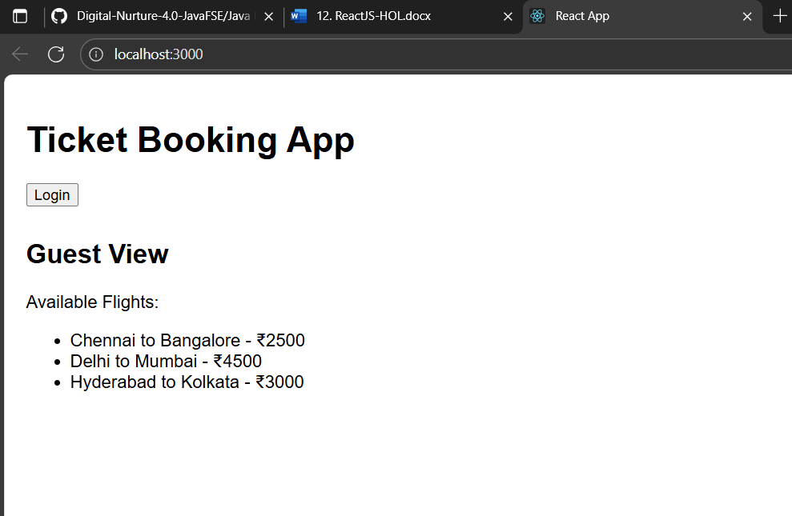
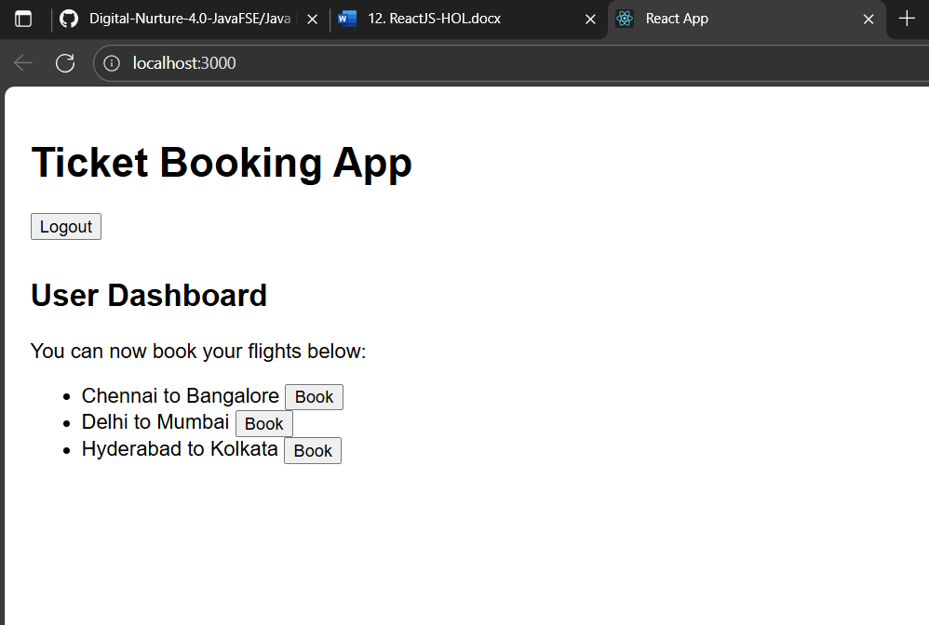

Hands-on 5: Creating a react bloggerapp
- Creating a react app named ‘bloggerapp’ using create-react-app
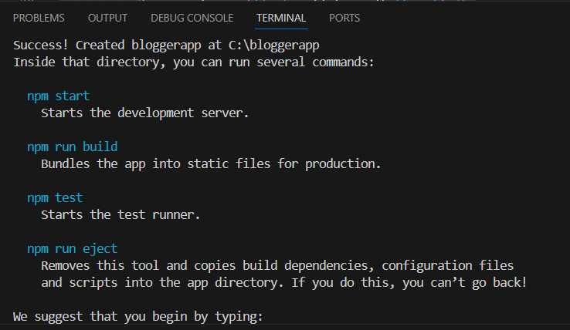
- Creating a folder components inside the src folder. Inside the components folder creating the following components
File name: BookDetails.js
import React from "react";
const BookDetails = () => {
return (
<div>
<h2>Book Details</h2>
<p>Title: React Simplified</p>
<p>Author: John Doe</p>
</div>
);
};
export default BookDetails;
File name: BlogDetails.js
import React from "react";
const BlogDetails = () => {
return (
<div>
<h2>Blog Details</h2>
<p>Title: Learning React in 2025</p>
<p>Author: Jane Smith</p>
</div>
);
};
export default BlogDetails;
File name:CourseDetials.js
import React from "react";
const CourseDetails = () => {
return (
<div>
<h2>Course Details</h2>
<p>Course: Full Stack Development</p>
<p>Duration: 3 Months</p>
</div>
);
};
export default CourseDetails;
OUTPUT (Book Details):
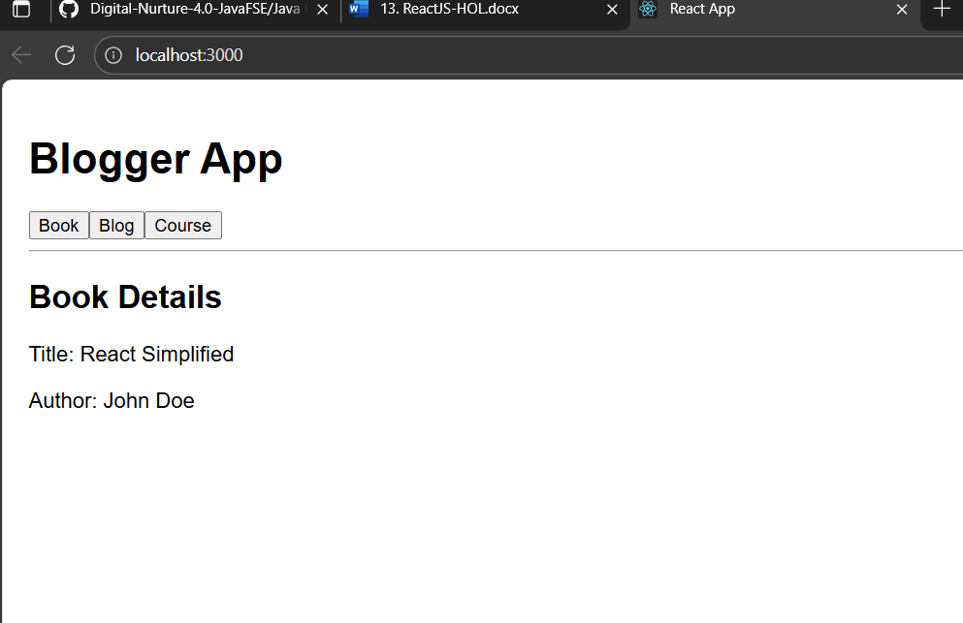

Blog Details
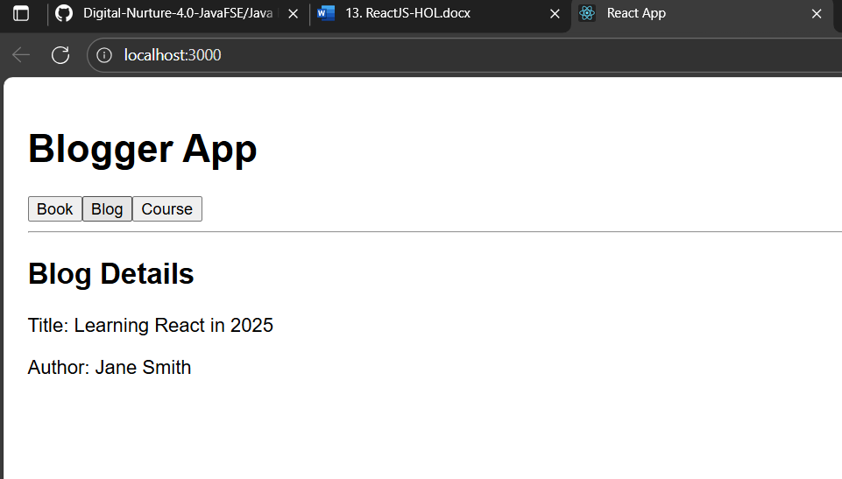

Course Details
